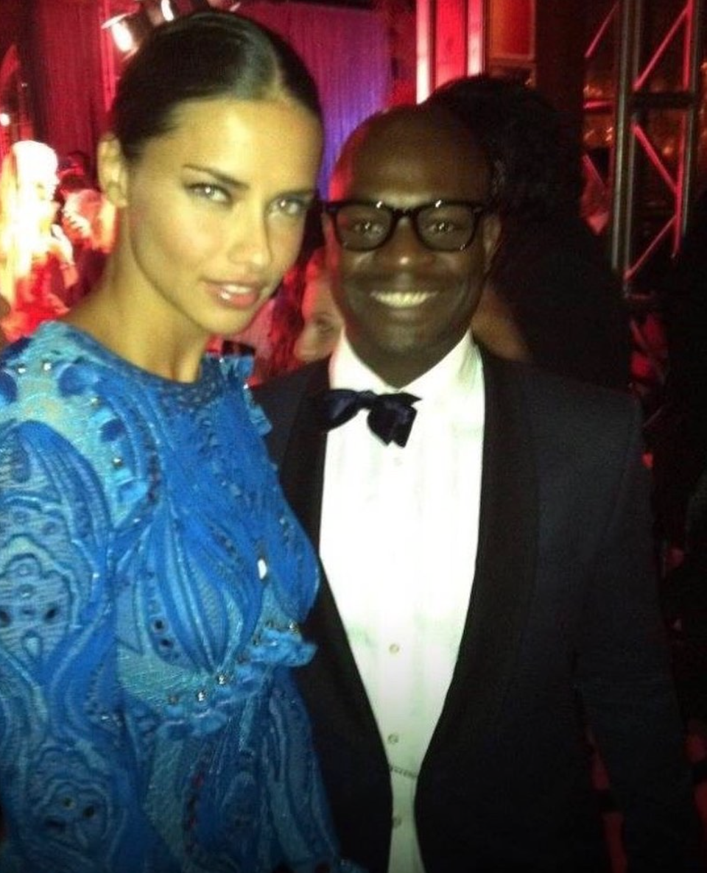

Celebrity Fashion Stylist Joseph Hobbs Spotted with Super Model Adriana Lima at the 2011 Victoria Secret Fashion Show Afterparty in New York

November 10, 2011

Celebrity Fashion Stylist Joseph Hobbs was with Super Model Adriana Lima at the 2011 Victoria Secret Fashion Show After Party at the Dream Downtown on November 9, 2011, in New York City. Also, he was seen chatting with other models including Miranda Kerr, Lily Aldridge, Lily Donaldson, Joan Smalls, Izabel Goulart, Doutzen Kroes , Lindsay Ellingson, Behati Prinsloo, Jacquelyn Jablonski, Joan Smalls, Sui He, Candice Swanepoel, Erin Heatherton, and a bevy of other Victoria’s Secret Angels. The Victoria Secret Fashion Show as the guest of Kanye West which was held earlier in the night at the Regiment Armory (Lexington Armory) in New York City on Wednesday, November 9th while broadcasted on the CBS Television Network on Tuesday, November 29th, 2011. The Victoria’s Secret Fashion Show is the most anticipated fashion event of the year and one of the celebrity-studded events you do not want to miss. It was an amazing night of bright colors, beautiful women, and eye-catching lingerie.
World-famous Victoria’s Secret Angels Miranda Kerr –wore the iconic angel wings and the $2.5 million Fantasy Treasure Bra. Joining the models for some high-energy performances were Nicki Minaj in an appropriately eye-catching get-up and Maroon 5, as well as Jay-Z and Kanye West. Adam Levine even killed his model girlfriend Anne Vyalitsyna during the show.

After walking in 20 runway shows for Victoria's Secret, supermodel Adriana Lima concluded her run in 2018. Hailing from Brazil, Lima began modeling as a teen and joined Victoria's Secret early on in her career when she walked during the 1999 fashion show. She officially signed a contract with the brand in 2000, making Lima a Victoria's Secret Angel for the next 18 years. In 2009, celebrity fashion stylist Joseph Hobbs was introduced to Andriana Lima by fashion critic Andre Leon during New York Fashion Week. Throughout her almost 20-year history with the brand, Lima wore a number of show-stopping looks, including giant Angel wings and even the coveted Fantasy Bra. Talking with Hobbs, he indicated that off the runway, Lima sought to maintain her image by carefully selecting various designer clothing and accessories.

As a celebrity fashion stylist Hobbs is instrumental in making sure his celebrity clients look they're very best in the public eye. Previous editions of the Victoria Secret Fashion Show included celebrities that Hobbs has a connection with that include the Black Eyed Peas, Jay-Z, Elton John, Elizabeth Taylor, Usher, Joaquin Phoenix, Adrian Grenier, Malin Ackerman, Natasha Bedingfield, Beyonce Knowles, Gerard Butler, Kings of Leon, Maroon 5, Sting, Mark Wahlberg, Terrance Howard, Josh Lucas, Alex Rodriguez, Martha Stewart, Eva Longoria, Ryan Seacrest, Hayden Panettiere, Gabrielle Union, Amanda Bynes, Jeremy Piven, Neil Patrick Harris, Molly Sims, Denzel Washington, P. Diddy, Derek Jeter, Lenny Kravitz, Eva Longoria, and Justin Timberlake.

